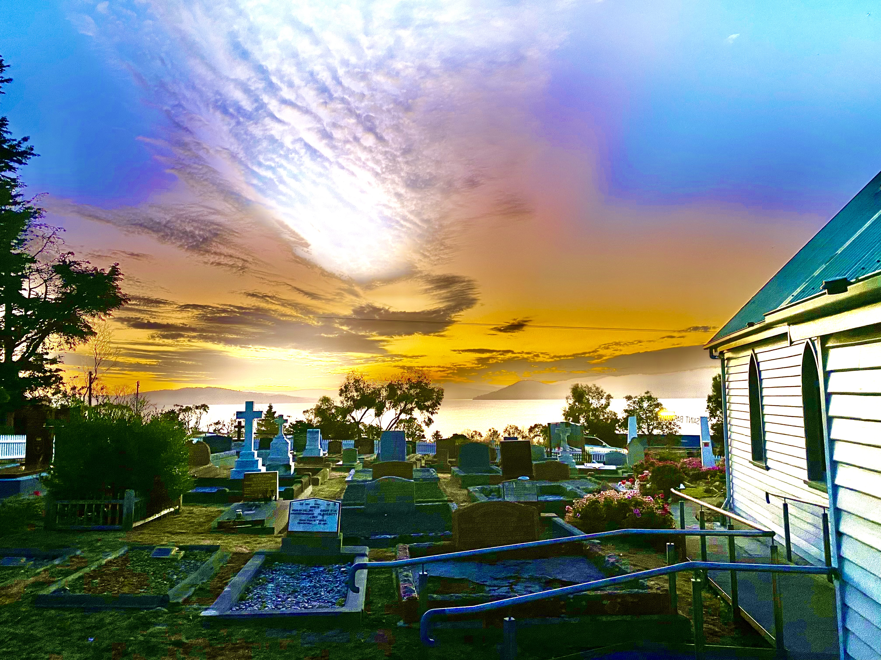


5th Annual Report and Balance Sheet

FOR THE FINANCIAL YEAR ENDING 30TH JUNE 2025

COMMUNITY CHURCH OF ST BARNABAS – SOUTH ARM INC.
(A.B.N. 78 104 384 664)

Contents

1. Association Declaration………………………………………………………………….………........…3

a. Our Mission………………….….………………………….…..….......................................4

- Our Vision………….……………………………………….………….……………….………........4

- Our History………………………...…………………………………………...………. ….…....….4

d. Our People………………….……………………………………….……………………...….....….5

- Structure of Board of Management….………….………...……………….………………..…5

f. Attendance at Meetings – Officers & Committee members………….……….…........6

- Director’s Report………………….……………………….............……………..……….…6

- Sub Committee Reports.

- Ministry Team Report………………………………………………………………….…….…8
- St Barnabas Cemetery Report………………………………………………………..……11
- Grounds Report………………………………………..............................................11
- Fund Raising Report…..………….…………………………………………………….…….12

- Financial Statements.

- Financial Statements for year ending 30 June 2024………………………………..14
- Independent Auditors Report…………………………………….……………………..…15
- Profit & Loss Statement…………………………………………………………………..….16
- Balance Sheet……………………………………………………………………………………17
- Depreciation Schedule……………………………………………………..………………..18

Association Declaration

I certify that I am an authorised officer of the association, and that all information outlined in this report is true and correct.

Name: Terrence A Roe

Position/title: Director & Chairperson, Board of Management, Community Church of St Barnabas – South Arm Inc.

Mobile: 0400 140 870 Email: troey1@bigpond.com

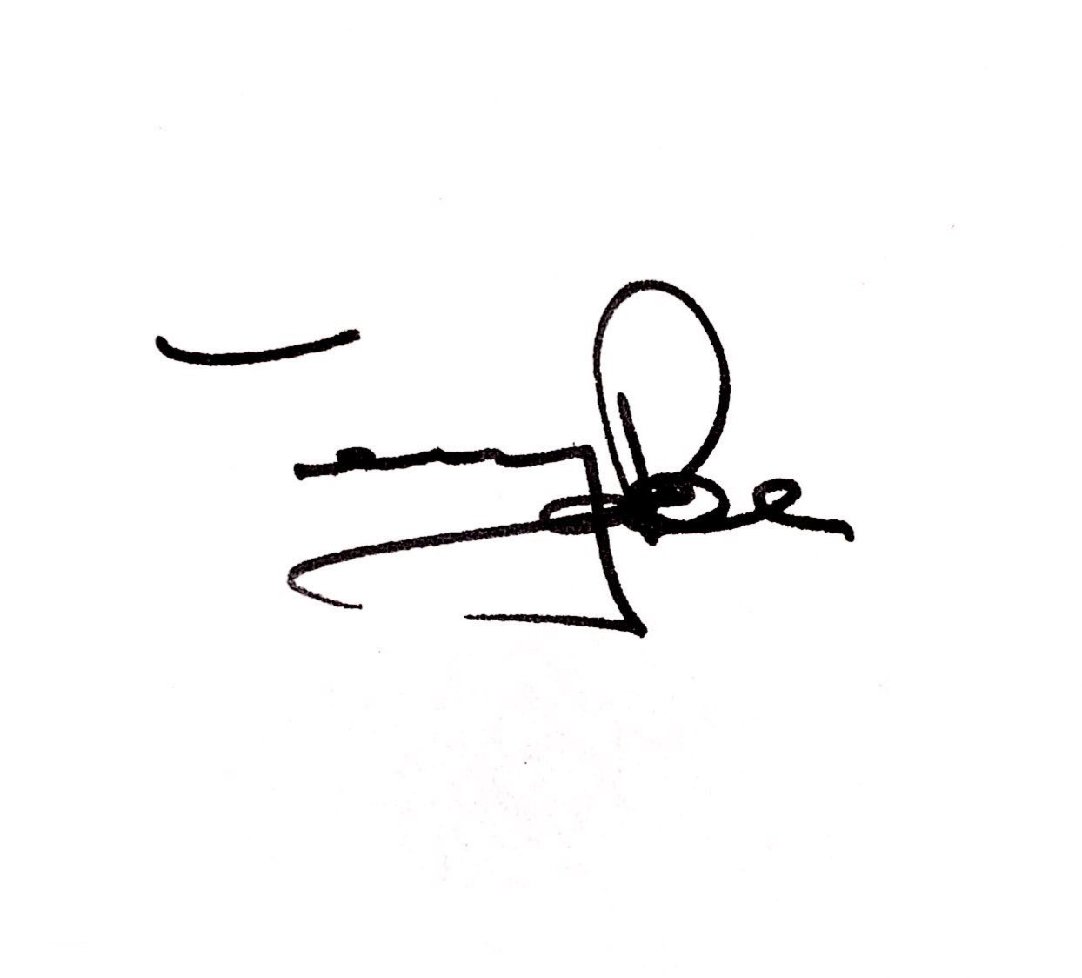
Signature: Date: 22nd of August 2025

Our Mission

- To provide an ecumenical church that is a vibrant centre of spiritual guidance, support and pastoral care for the local community.

- To maintain the historic building and cemetery as a revered resting place for loved ones throughout the generations.

Our Vision

- For St Barnabas church to be a welcoming place of Christian worship and spiritual comfort. To enable the community to celebrate and preserve the historical significance of the church and the cemetery.

Our History

St Barnabas is a historically significant building and has an equally important cemetery attached. The cemetery pre-dates the building of the church, which was built in 1892.

It is a testament to the belief of early settlers in the South Arm peninsula area that a place of worship was considered as necessary in this area.
A local family (the Gellibrand’s) gifted the land to the community, and the church building itself was financed by donations from local community members, and built by those same people, with the express purpose of providing a church for families in this area to attend.

In 1893, £100 was loaned interest free to the community by William and Robert Calvert. The church was consecrated ‘without debt’.
The stained-glass window was donated by the Calvert family and dedicated to the children of William Calvert 1840-1935 (Hannah and Alfred – who was the first Church Warden of St Barnabas).

Significance of the cemetery.

St Barnabas has a historically significant cemetery attached. In fact, the church was built over 30 years after the cemetery was first established.

The first recorded burial is Jane Alomes 1858.

The cemetery contains graves of the ancestors of several local families, the Gellibrand’s, the Calvert’s, the Alomes, the Musk’s and many others, all names that represent the early history and the pioneers who settled in the region of South Arm & Opossum Bay.
The cemetery also contains the graves of ex-service men from the 2nd World War and later conflicts. There is a memorial to a soldier from the 1st World War (Horace Calvert). There are 2 Australian War Graves Commission graves – which are cared for under the auspices of the Federal Government.

Our people.

In compliance with the Australian Business Register, there are 3 officers (1 x Director & 2 x Officers) of the association.

Terry Roe JP Director & Chair
Herman Westerhof Finance Manager & Public Officer
Bill Linton Secretary & Deputy Chair

Committee:
Linda Roe
Rachel Todd
Lynette Aylett
Pam Lake

Structure – Board of Management

Director/Chairperson
Terry Roe JP

Finance Manager & Public Officer

Herman Westerhof AAM
Deputy Chairperson & Secretary
Bill Linton
William (Bill) Linton

Sub Committees

Risk Management

Board
Church & Hall

Linda Roe
Ministry/Church

Lynette Aylett
Rachel Todd
Linda Roe

Cemetery Manager

Rachel Todd

Ground Maintenance

William (Bill) Linton

Fund Raising

Pam Lake

A total of 9 Board meetings has been held since the AGM meeting held on Friday 30th of August 2024.

Name | Sep-2024 | Oct-2024 | Nov-2024 | Feb-2025 | Mar-2025 | Apr-2025 | Jun-2025 | Jul-2025 | Aug-2025 | Total
Terry Roe | ✓ | ✓ | ✓ | ✓ | ✓ | ✓ | ✕ | ✓ | ✓ | 8
Bill Linton | ✓ | ✓ | ✓ | ✓ | ✓ | ✓ | ✓ | ✓ | ✓ | 9
Herman Westerhof | ✓ | ✓ | ✓ | ✓ | ✓ | ✓ | ✓ | ✓ | ✓ | 9
Linda Roe | ✓ | ✓ | ✓ | ✓ | ✓ | ✓ | ✕ | ✓ | ✓ | 8
Rachel Todd | ✓ | ✓ | ✓ | ✓ | ✓ | ✓ | ✓ | ✓ | ✓ | 9
Lynette Aylett | ✓ | ✓ | ✓ | ✓ | ✓ | ✓ | ✓ | ✓ | ✓ | 9
Pam Lake | ✓ | ✓ | ✓ | ✓ | ✓ | ✓ | ✓ | ✓ | ✓ | 9
Total Attendance | 7 | 7 | 7 | 7 | 7 | 7 | 5 | 7 | 7 | 61

Director’s Report – AGM 22nd of August 2025

I am pleased to present this 4th Annual General Report of our Year in Review 2023-24 which offers an overview of activities and events concerning the Community Church of St Barnabas-South Arm Inc.

This report is presented on behalf of the Board of Management, herein after referred to as the Board.

Outlined in this Year of Review 2023-24 is what I believe to be a comprehensive outline of the successes of the sub committees. It also provides information on the future direction for the church and cemetery.

The Board is made up entirely of volunteers who donate many hours of their time to ensure the church and cemetery continues to be managed in the best possible way, on behalf of the community. It remains an important focus of faith for its regular parishioners and for the wider peninsula community.

It is important to remember that the property situated at 3337 South Arm Road – the Community Church of St Barnabas-South Arm including the cemetery is owned by the community. The Board manages both the Church & Cemetery on your behalf, and as need arises, we require help from the wider community to ensure maintenance issues comply with current standards.

Membership. All members of the community are encouraged to become members of St Barnabas Church. As an incorporated body, we need a membership base to comply with the Incorporations Act. The cost to become a member is $5 per year. Please consider supporting this community church by completing a membership form.

Some significant achievements over the last 12 months include:

- The church has been repainted – colour: Tranquil Retreat.
- The church’s electrical board has been updated with a new board & re-wired where necessary.
- 2 new flood lights have been installed at the front of the church for added security.
- New power point switches installed inside the church (back wall) to turn the ceiling heaters on/off.
- New TV display unit installed on the rear wall of the church to aid in the delivery of services.
- Toilets in the Gellibrand Fellowship Hall have been repainted.
- Electrical circuit in the Gellibrand Fellowship Hall upgraded.
- The church’s web page is up & running – type in stbarnabas.au into your browser to access the page or scan our QR Code.
- Created a QR Code.
- Completed the painting of the new side fence.
- Established and created a memorial garden along the front of the cemetery.
- A car park has been established at the rear of the church for people to park their car.

Short term issues the Board is investigating.

Below in dot point form, are just some of the issues the Board are investigating.

- Deductible Gift Recipient (DGR) status. As reported in the 2022-23 AGM report, donations made to St Barnabas are not tax deductible. The Board is continuing investigating the process of obtaining ‘DGR Status’ so that people making donations will be able to claim reimbursement on their yearly tax forms.
- In the process of purchasing software that will help manage the cemetery records and provide a digital database.
- 2025 Calendar. The Board has produced its second calendar depicting iconic scenes from around our peninsula. The calendar will be available for purchasing towards the end of September 2024, just in time for Christmas and the New Year. Cost to purchase a calendar is $15.00. You can pre-order your calendar by contacting Linda Roe on email: lindaroe30@gmail.com or mobile: 0438 679 320.
- Painting the Gellibrand Fellowship Hall. With help from community members, the external walls of the Hall are to be painted (in the same colour as the church) during this coming summer.
- St Barnabas web page. Continue to develop and improve the St Barnabas web page.
- Replace the electric stove. The current stove in the kitchen is old and is not working properly. The Board hopes to replace the current stove with a new more modern stove before Christmas 2024.
- Creating usable space at rear of Church. Plans are underway for the area between the church and the storage shed at the rear of the church to be developed creating an area that will add enormous benefit to the property. The Board has engaged Lyden Builders to develop the area with excavation commencing in a few weeks’ time. The aim is to level & concrete the area. This should be completed by end of October.

Long term issues that need attention.

- On advice from the painters who painted the church, the entire front wall (main entrance to the church off the footpath) needs to be replaced in approximately 8 -10 years’ time, due to rotting weather boards.
- Redesign a new kitchen that meets Clarence City Council’s requirements that will enable the preparation and sale of food. The Board is in the process of securing quotes from suitable companies who supply kitchens.
In closing, the community can be proud of the Board for their achievements and respectful care of the church & cemetery. A lot of long hours, hard work and commitment by every member of the Board has been devoted to making improvements to the church and cemetery. As chair, I thank each one for their positive contribution in continuing to ensure St Barnabas church and cemetery is and remains a focal point of faith and history for the community.

To the community members of the South Arm Peninsula and to members further afield, on behalf of the Board, thank you for your continued support and for all the work you do in helping us to preserve St Barnabas and cemetery for generations to come.

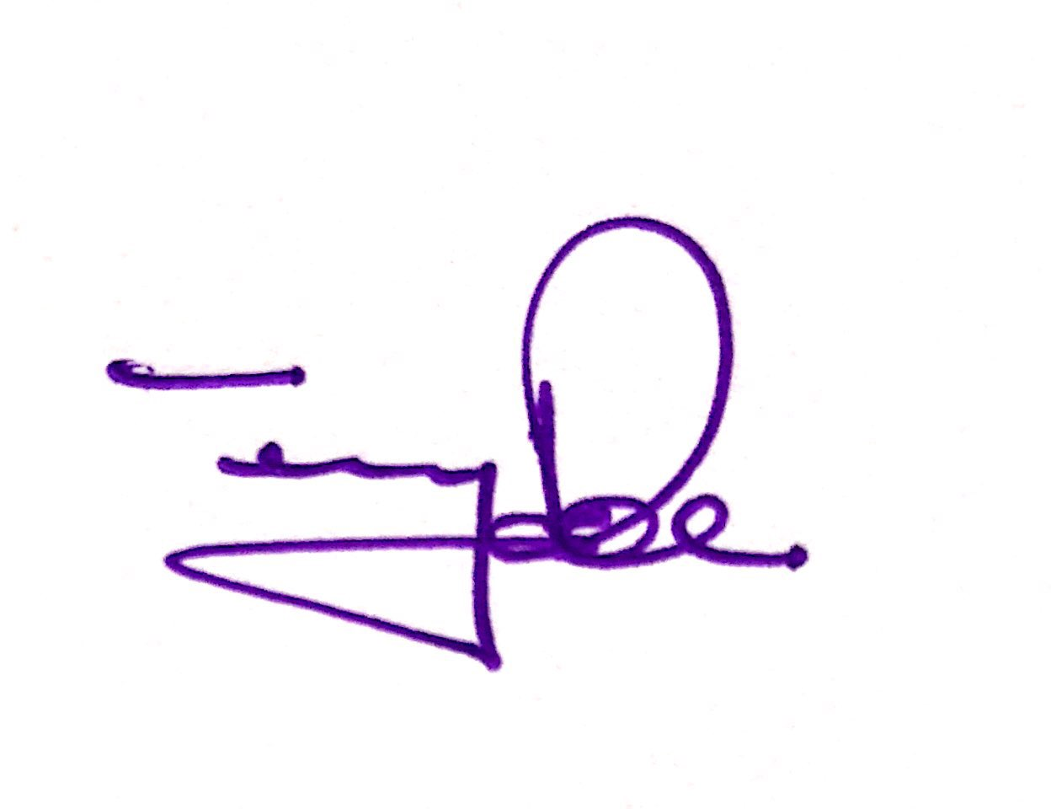

Terry Roe JP
Director 22nd of August 2025

Ministry Team Report for A.G.M. 2025

The St Barnabas Ministry team is responsible, under the auspices of the Board, for the planning and organising of regular church services. There has been a church service at St Barnabas every week since it became a community church in 2021. Our role also involves planning special services and church activities and events within the community.
The Ministry team meets monthly. In 2024-2025 these people are on the Ministry team: Lyn Aylett, Jane Beavan, Linda Roe, Rachel Todd and Jean Williams.

Regular church services.
Over the past 12 months, we have continued to maintain a routine of Sunday services at 10.00am. We have been fortunate to be able to rely on Rev. Beverley Elliott, Rev Paul Elliott, Rev Andrew Lake, and Lyn Aylett to provide interesting, thoughtful and uplifting services for our congregation. Lyn has completed a certificate in Bible studies and is in the final year of studying for her Diploma in Ministry. She has taken on the role of liaising with Ministers and frequently acts as Deacon during services. Our services follow a regular pattern each month.
In a 4-week month:
Week 1; Prayer and Praise with Lyn.
Week 2; Iona communion service with Rev Beverley.
Week 3; Traditional Anglican communion service with Rev Andrew.
Week 4; Communion service with Rev Paul.

When the month has a 5th Sunday, we have introduced special services, sometimes with guest celebrants and speakers. Representatives from churches from other denominations have led services, or contributed to services, including Hans Kelder from the Reformed Church, Graham Roberts from the Gideon Society, Maggie Mead from the Leprosy Mission, and Lyn Gallagher from Samaritan’s Purse. Rev Rodney Curtain and Rev David le Rossignol from the Anglican Church have also taken services for us.

Future services.
The Ministry team is actively promoting St Barnabas as a place for other Christian denominations to hold their own services for their congregations on the peninsular. St Barnabas is now well-established as a Community Church and can invite those other than Anglican tradition to conduct services. We hope that they will have the capacity to provide services, and that they will be well supported by the local community.
We expect these services to be held at times other than 10.00 am on Sundays, i.e. any other time on a Sunday or at any other time/day during the week. There will be a nominal cost to hold services (to cover power costs etc).

Special services.
During this year, several special services have been held at St Barnabas and have been warmly received and well-attended by our church community and friends.
- a Pet Service was held on St Francis of Assisi Day in October. All community members and their animal companions were invited to come along. Each pet received a special blessing. The service was led by Rev Beverley who highlighted the work of St Francis, the Patron Saint of animals and the environment. This year our Pet Service will be held on Sunday October 12th. Every person and every pet is welcome.
- Mother’s Day in May provided a special intimate service - a time to give thanks for our Mums, and to remember those sadly missed.
- In July Rev Beverley led a very interesting and thought-provoking service to mark Naidoc Week. The church was decorated appropriately with Aboriginal design prints and native plants to set the scene by Lyn. Rev Beverley provided a well-researched and inspiring service.
- On Ash Wednesday – the beginning of Lent – Rev Paul led the congregation in a special contemplative evening service.

Vale Paul Davidson.
During the year, the St Barnabas family sadly farewelled Paul Davidson. Paul was a member of our congregation. He was part of the group that worked extremely hard to organise a way to purchase the church, notably being instrumental in researching the possibility of gaining heritage listing for the church and cemetery. He was a founding member of the Board following St Barnabas becoming a Community Church.

Church Events.
Shrove Tuesday is also known as Pancake Day, and a tea was held in the church hall for all community members. The hall was filled with 20 happy people enjoying delicious pancakes and sharing friendship.
Lyn and Rachel attended the Anzac Day and Remembrance Day services at the South Arm Memorial Park, laying wreaths on behalf of the St Barnabas community.
A special event was held in early December to sincerely thank all our wonderful supporters and volunteers for their help throughout the year. Without their efforts, St Barnabas would not be able to function as a community church.
In early August, a group of people from St Barnabas went to Eastlands to watch a film entitled “The First Hymn”.

Participation in Community Events.
Once again, St Barnabas was invited to participate in the local Winter Festival. Two members of the Ministry team joined the Festival committee and helped to ensure that St Barnabas’ involvement was positive and far-reaching. In June, 2 workshops were held as part of the festival: Rock painting and Plant Propagation. Both workshops were well attended and helped to raise the profile of the church in the community as well as providing much needed funds. The plant workshop was very much an ‘in house’ event, as those leading the workshop are members of the hard-working cemetery/church grounds maintenance team.
In July a Monster Book and Garage Sale was held, and this was both a successful community event and a fund raiser. Unfortunately, the weather was against us and the planned “Petting Zoo’’ from Cricklewood Animal Sanctuary was unable to go ahead. This was disappointing, as many families with young children had come along to enjoy meeting the animals.
Our regular monthly market stall continues to be well supported through donations of items to sell and people looking for a bargain. We have put out a request for more “helpers” both on market day and to assist with preparation and organising the stall.
Each community event in which St Barnabas participates, provides opportunities for the church to have a substantial visible presence in the community.

Community support.
Our annual project to fill Christmas Child shoeboxes was supported by community members again this year. We forwarded 70 boxes to be sent to children in war-torn Ukraine. We sincerely thank all those who helped with this project.
Tinned goods and dried foods have been collected on an ongoing basis and are taken to City Mission and St Vincent de Paul.
The Leprosy Mission has again been supported by members of the congregation. The annual lunch, held at Midway Point, and a morning tea held in Lindisfarne were both well attended, and raised valuable funds for the ongoing treatment of leprosy throughout the world.
Boxes of books were donated to Rotary for their bookstall project.

Fund-raising initiatives.
150 copies of our Paradise Peninsular calendar were sold this year, and this initiative is proving to be very popular and a major fund-raiser for St Barnabas. Thanks must go to Patsy Duggan for her expertise and hard work in compiling and designing the calendar. Our thanks also go to the photographers who provided such wonderful photographs that show-cased our local area perfectly! The 2026 calendar will soon be in production and will be available for sale in October.

Bible Study.
Our Bible study group meets in the church hall at 10.30 am every Friday. This group has been meeting for 31 years, and many people have come and gone in that time. Currently there are 10 members who meet regularly. The study is led by Jane Beavan, and we give our sincere thanks to Jane for her years of leadership and knowledgeable instruction. She has provided Christian guidance to all past and present members of the group.

Future community support.
Now that we have a refurbished meeting hall, the Ministry team and wider congregation are planning to hold regular morning and afternoon tea get-togethers to encourage wellbeing and companionship. It is hoped that people will come along to enjoy each others company over a meal, and perhaps craft activities such as knitting or crochet, card games or other relaxing pastimes.

St Barnabas is a community church that belongs to all of us in the South Arm and Opossum Bay communities.
We thank most sincerely everyone who has made this vision of owning and running a church for our community a reality.

The current Ministry team is taking care of St Barnabas for you.
Everyone is welcome at any time. Come along, see what is happening and have your say. Your input is always welcome.

May God bless our local community.
Linda Roe.

Grounds Report
for
Annual General Meeting
22nd August 2025
Aim
The maintenance and improvement of the amenity of the church grounds is seen as a strategic priority for the Church Board.
Improved ground’s aesthetic and amenity sends a clear message to the community that the board and its members are active in ensuring that our church is valued and important.
- Promote a sense that this area is important and significant to the parishioners and the local community.
- Improved grounds that maximise the aesthetics of the area are seen as an important marketing tool for the broader community use of the church for significant occasions such as weddings, christenings/name-giving ceremonies, and funerals. This will provide an income source to support the ongoing activities of the board for the church parishioners.
- The maintained grounds allow for general ease of access for the wider public who may wish to explore family heritage and the historical significance of the Arm.
Activity
- The grounds team meet on the first Saturday of the month.
- While meeting every month, some volunteers come along in intervening times to check on plants that have been newly planted, watering during the summer season.
- During this year we have averaged 7 people, with a maximum of 10. The work covered is a testament to this hardy group.
- The community support we obtain is generous, with people giving their time and their expertise. Our community propagate the plants that we are growing, collect rocks from surrounding properties, along with pine bark and materials that we use. We are very lucky.
- Our projects this year have been:
  - Putting in path and retaining wall behind hall.
  - Creating new garden behind the church hall.
  - Putting in a garden near our new lawn cemetery.
  - Providing a community propagation workshop, led by our garden designer and a horticulturist. It was positively received.
- Before the end of the year, we hope to complete the exterior painting of the hall.
- Finishing of the memorial garden available for community members in which to spread ashes. A plaque marking the garden has been put in place.
- Started marking out unmarked graves.
- We were fortunate to receive a donation of $500 for plants for the garden. It has been greatly appreciated and will be put to good use.
Future Focus
The grounds team would like to:
- Provide descriptions for headstones where the lettering is obscure or damaged.
- Provide signage and direction to the Lone Pine area and research and acknowledge community members who may have served in Gallipoli in the first world war.

Bill Linton

Fundraising report 2024/2025

Current
The Board is extremely thankful for the generosity of so many which has enabled continued improvement of the property.
During the financial year 2024/2025 the Community Church of St Barnabas sufficient funds have been received through the generous support of the community.
Major work has been completed on the cemetery upgrade including the lawn cemetery and garden.
The Gellibrand Hall has been upgraded with a council approved kitchen and interior paint.
The outdoor patio area has been completed with a concrete area and child safe fencing installed.
Once again major works of repairs and maintenance have been funded through the Market, Garage Sales, calendars and through the generous support of money, goods and time by community members, tradies and politicians. Financial details are in the Treasurer Report.

Ongoing
St Barnabas Church building, Gellibrand Hall and the cemetery will continue to require ongoing maintenance and improvements. Whilst some are long term requirements such as replacing the entire front wall of the church, others are aimed to be completed in the coming year. This includes exterior repair of timbers and painting of the Gellibrand Hall, a roof added to the outdoor patio area and soft fall covering over the concrete.

The Cemetery, a community owned asset, is the resting place of many locals and is fully functioning. As such it is required to comply with current legislation of maintenance and record keeping. Administration always has a cost component.
Increasing costs are occurring. This has been particularly evident in fire and insurance fees.
The completed kitchen and hall upgrade during the coming year will provide opportunity for smaller sized hall rentals. The community will be encouraged to consider this as a suitable venue.
Membership has increased however this will be encouraged more due to community ownership. The Board is giving consideration as to how the community can be more invested long term in this historic and important asset.
The seasonal markets, garage sales, EFT donations, general giving and Calendars will continue to support required income.

There is grateful appreciation for all the volunteers and supporters who in so many ways are enabling the Church and Cemetery to be a property the community can be proud of. The Board looks forward to the coming year with confidence.

Pam Lake. August 2025

ST Barnabas Cemetery Report - 2024
From July 1st, 2023, to 30th June 2024 there has been 3 Exclusive rights certificates issued. These certificates give the holder exclusive rights to a particular burial plot or a niche in the Columbarium for 25 years from the date of issue.

Two double depth Graves have been opened the grave of Leslie Staples to bury Nancy Staples and the Grave of Robert Harrex to bury Lesley Harrex.

There have been 3 interments of ashes into the Columbarium those of both John and Patricia Calvert and a plaque only for Joan Griffiths, may all R.I.P.

Plans are now underway to layout the first row of the lawn cemetery on the Opossum Bay side of the church, although the initial cost will be slightly more this will make the overall cost of a burial cheaper as only a plaque will need to be purchase and not a full gravestone and the area easier to maintain by future volunteers.

A special thank you to the monthly working bee volunteers the Cemetery grounds is looking wonderful for a place to rest. The new memorial garden at the front of the church, a place to put loved one’s ashes with a plaque of remembrance, is beginning to take shape.

Let us remember all those that have found a place to rest in our community cemetery this past year.

Rachel Todd.

